Dataset
The project uses the SetFit version of the Enron Spam dataset, available through Hugging Face. The source contains 33,716 emails: 31,716 in its training partition and 2,000 in its test partition. The labels are ham (0), meaning legitimate email, and spam (1). The source partitions are audited before creating the final splits to avoid comparing models on duplicated or overlapping messages.
Duplicate detection normalizes case and whitespace without changing the text presented to the models. From the source training partition, cleaning removes 51 empty records, 3,137 additional duplicate rows, and 372 records whose normalized text also appears in the source test partition. The test partition contains 19 additional duplicate rows, which are also removed. No conflicting label groups were found within either source partition. This leaves 28,156 development emails and 1,981 test emails.
The development data is split into training and validation using an 80/20 stratified split with seed 42. Stratification preserves approximately the same class proportions in both partitions. The resulting data is saved once and loaded by the experiment notebooks so the models use the same cleaned examples. Normalized text overlap is checked across all final partitions.
Partition | Emails | Ham | Spam
Training | 22,524 | 11,681 (51.86%) | 10,843 (48.14%)
Validation | 5,632 | 2,921 (51.86%) | 2,711 (48.14%)
Test | 1,981 | — | —
Test class counts are omitted here; the test partition remains separate from model selection. Text is lowercased and tokenized into words and individual punctuation marks. A 10,000-entry vocabulary is built from training text only, with a minimum frequency of two and reserved IDs for padding (0) and unknown tokens (1). Sequences are truncated to 256 tokens and padded within each batch. The limit truncates 32.2% of training emails and discards 49.6% of their tokens, which reduces computation but removes information from longer messages.

Recurrent model
The recurrent model is a single-layer, unidirectional LSTM trained from scratch. Each token ID is mapped to a learned 64-dimensional embedding, and the LSTM reads the embeddings in sequence using 128 hidden units. Its final hidden state represents the email. Dropout of 0.1 is applied before a linear layer produces two class scores. The model contains 739,586 parameters: 640,000 in the embeddings, 99,328 in the LSTM, and 258 in the classifier.
The LSTM was selected to preserve token order while using gates and a cell state to control how information is retained. This follows the course discussion of recurrent memory and gradient stability. The final hidden state provides a compact email representation, while one layer keeps the model size modest. Packed sequences exclude padding from recurrent processing, so the final state corresponds to real content. A verification check confirmed that appending extra padding leaves the scores unchanged.
Training uses cross-entropy loss, AdamW with weight decay 0.01, batches of 64, and gradient clipping at norm 1.0. Learning rates of 0.001 and 0.0003 are compared over five epochs with seed 42. Their best validation macro F1 scores are 0.9792 and 0.9744, respectively, so 0.001 is retained. The model is then evaluated across seeds 42, 123, and 2026, reusing the selected seed-42 run. Each run keeps its checkpoint with the highest validation macro F1 within five epochs. Macro F1 weights the ham and spam F1 scores equally. Test data is excluded from vocabulary fitting and hyperparameter selection.

Ablations

Recurrent model forget gate initialization
What changed. The controlled variant changes the effective initial forget-gate bias from 0 to +1. Both LSTM bias vectors are first zeroed, and +1 is then assigned only to the forget-gate slice of the input bias vector. The architecture, parameter count, data, seeds, learning rate, optimizer, and five-epoch budget remain unchanged. This is an initialization ablation rather than removal of a component.
Why it was tested. A positive initial forget-gate bias increases the initial tendency to retain cell-state information. The experiment tests whether this choice helps the model learn useful email representations within the available budget. It does not directly measure the duration of memory or establish that the model learns longer dependencies.
Seed | Validation bias 0 | Validation bias +1 | Test bias 0 | Test bias +1
42 | 0.9792 | 0.9803 | 0.9823 | 0.9833
123 | 0.9815 | 0.9799 | 0.9813 | 0.9793
2026 | 0.9778 | 0.9799 | 0.9808 | 0.9783
Mean ± SD | 0.9795 ± 0.0019 | 0.9800 ± 0.0002 | 0.9815 ± 0.0008 | 0.9803 ± 0.0027
All table scores are macro F1; SD is the sample standard deviation across the three seeds. Each test score comes from the checkpoint selected using validation performance. The +1 variant selects epoch 4 for seed 2026; all other runs select epoch 5. All runs still complete the full five-epoch budget.
What the results show. The change improves validation macro F1 for two seeds and reduces it for one. Its mean validation advantage is approximately 0.05 percentage points. On test, the +1 variant improves seed 42 but reduces seeds 123 and 2026. Its mean test macro F1 is approximately 0.12 percentage points lower and its spread is larger. The results therefore do not show a consistent benefit from +1 initialization on this dataset under the selected budget.
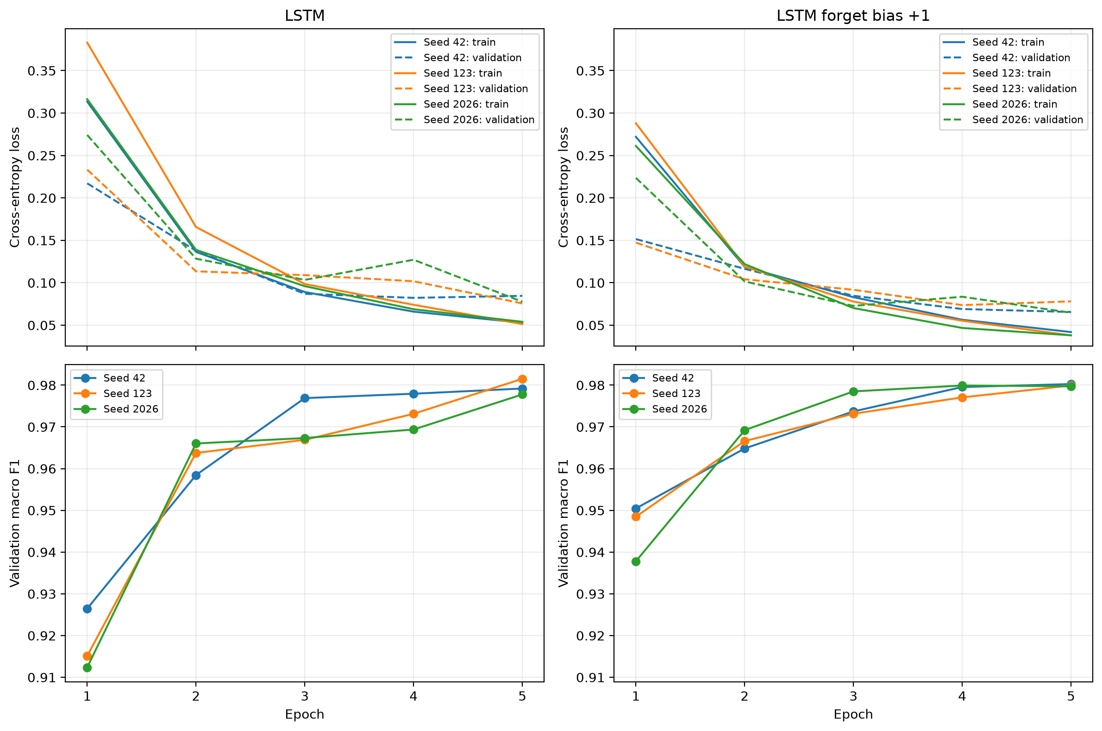
Figure 1. Loss and validation macro F1 across three seeds for the standard LSTM and forget-bias variant. Dashed loss curves indicate validation. Both variants approach similar validation scores by epoch 5. Source: saved LSTM experiment histories.

